**Name -: Aditya Babaso Birangaddi**

**Roll No -: 47**

**Enrollment No -: 1915770160**

**Practical No 8**

**Sample Code-:**

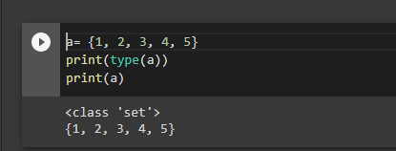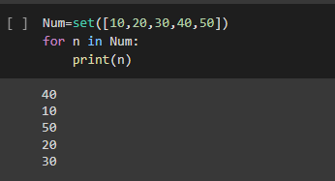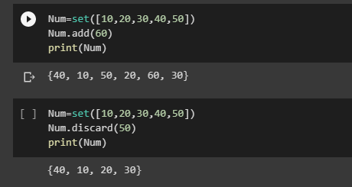

**1. Write a Python program to create a set, add member(s) in a set and remove one item from set.**

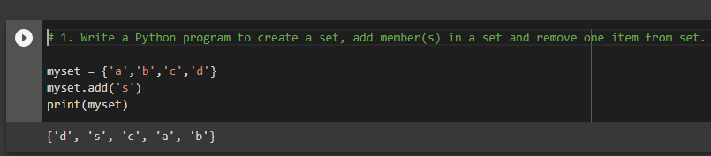

**2. Write a Python program to perform following operations on set: intersection of sets, union of sets, set difference, symmetric difference, clear a set.**

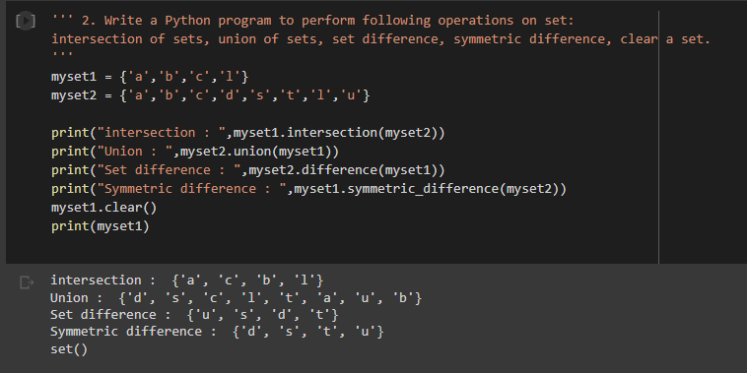

**3. Write a Python program to find maximum and the minimum value in a set.**

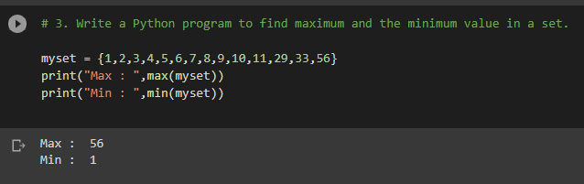

**4. Write a Python program to find the length of a set.**

